- Consider the following Dilbert cartoon? Would it be possible for a PRNG to spit out 6 NINEs in a row?
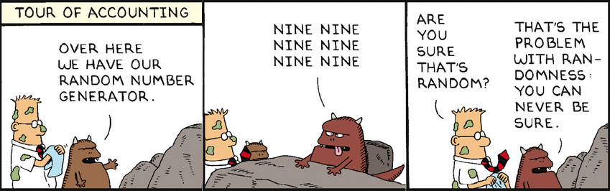
- Are slot machines fair? Why or why not?
- Is it possible to devise a method that would allow you to win consistently on a slot machine?

Portfolio Reflection Questions
Make a copy of this document in your Portfolio Assignments folder and answer these questions in the spaces below. Once complete, turn in this assignment according to the steps given by your teacher.

4.7 Pseudo Random Numbers Curriculum Page

Answer the following questions.

1. Consider the following Dilbert cartoon? Would it be possible for a PRNG to spit out 6 NINEs in a row?

Answer

2. Are slot machines fair? Why or why not?

Answer

3. Is it possible to devise a method that would allow you to win consistently on a slot machine?

Answer

